High Altitude Electromagnetic Pulse (HEMP) and Lightning (LEMP) Protection for HF Bands (1-40 MHz)

These coaxial protectors dramatically reduce electrical energy from high-speed HEMP or Electro-Static Discharge (ESD) or lightning activity. The HF bands are particularly difficult to protect, since much of the energy is in the pass band. NexTek has optimized the circuits to provide maximum suppression, while allowing desired operational throughput. These compact protectors are compliant to MIL-STD 188-125 and MIL-STD 461 pulses.

FEATURES:

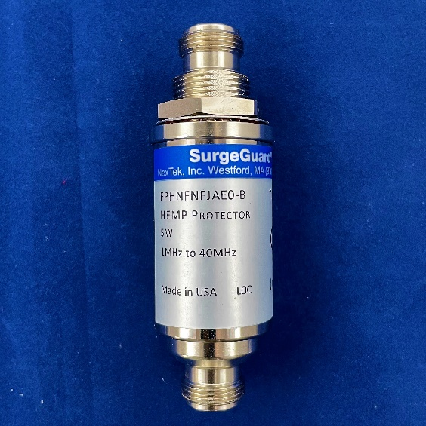
- High-Speed Protection Design
- Ultra-Low Let-Through Energy
- Type N Connectors
- 1-40 MHz Operating Frequency
- DC Block
- A HEMP Tested and Verified Design
- Excellent Insertion Loss and Return Loss
- Bulkhead Mounting

APPLICATION:

- Low Power Transmitters up to 5W
- MIL STD 188-125 Transmitter Applications

Transient Specifications
LEMP Waveform | IEC 61000-4-5 8 x 20µs
LEMP Maximum Surge | 30 kA
LEMP Multi-Strike (10x) | 20 kA
LEMP Let-Through (@ 2kA) | Peak Voltage (V) |  | Energy into 50Ω (μJ)
 | 35 |  | 1.1
HEMP Waveform | MIL-STD 188-125 20x500ns
HEMP Surge (250x) | 300kV/5kA
HEMP Residual (20x500ns @ 1kA) | Peak Current (A) | Peak Rate of Rise (A/s) |  | Root Action (A√s)
 | 0.80 | 3.0x10⁸ |  | 1.4x10⁻⁴

RF Bands and Performance
Impedance | 50Ω
Frequency | 1 – 40 MHz
VSWR (Typ. / Max)
1-2 MHz | 1.10 / 1.20
2-10 MHz | 1.06 / 1.10
10-40 MHz | 1.08 / 1.12
Insertion Loss (dB) (Typ. / Max)
1-2 MHz | 0.07 / 0.15
2-10 MHz | 0.05 / 0.07
10-40 MHz | 0.15 / 0.3
RF Power | Watts | Vpeak
 | 5 | 24
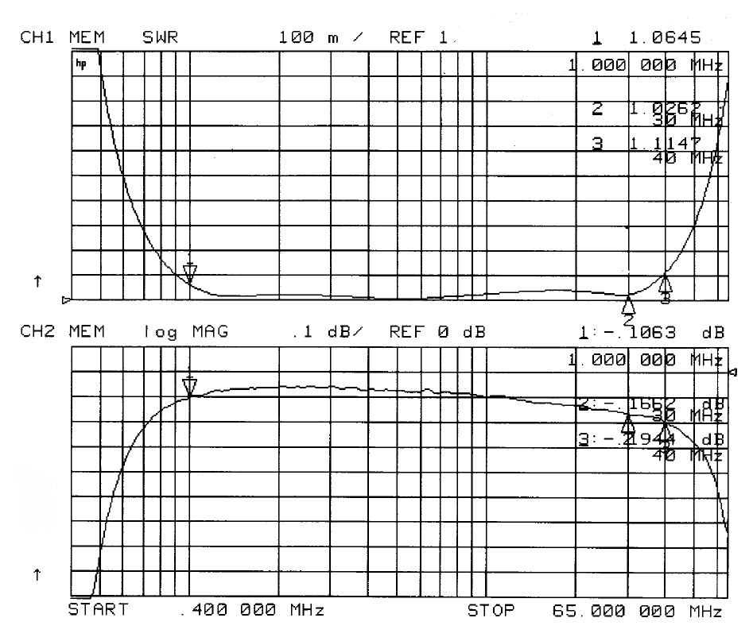

Environmental Specifications (*when mated with sealed connectors)
Temperature Range | -50°C to +90°C
Salt Fog | MIL-STD 202 Method 101D / Cond B 24Hrs*
Water Proof | IEC529 IP68*
Moisture Resistance | MIL-STD 202 Method 106E (65°C/98% RH condensing/240 hours)*
Temperature Shock | MIL-STD 202 Method 107D / Condition B-1 (25x @ -65°C to +125°C)
Life (Elevated Temperature) | MIL-STD 202 Method 108A / Condition A (96 hours at 100°C)
Vibration | MIL-STD 202 Method 204D / Condition D (10Hz-2kHz 0.06” DA/20g)
Mechanical Shock | MIL-STD 202 Method 213 / Condition A (50g/11ms ~24”)

Material and Finish
Body Material | Aluminum
Body Finish | Nickel
Connector Material | Brass
Connector Finish | Nickel
Center Pin Material | BeCu
Center Pin Finish | Gold
